Creating ER Diagrams with Visio Pro
Visio Corporation was founded in 1990 by former software developers from Aldus Corporation (the PageMaker folks). The first version of their business drawing program was marketed in 1992. Microsoft acquired the Seattle-based company in 1999, and today the product line includes four major versions: Visio Standard, Professional, Technical and Enterprise Editions. Collectively, the Visio products are the market-share leader for business drawing tools.
Visio can be used to quickly create a wide rage of drawings: building blueprints, street maps, project timelines, program flowcharts, network diagrams, data flow and process flow diagrams, ...
This document will illustrate the creation of crow's foot ER diagrams with the Professional Edition of Visio 2002. This version is installed on all computers in the CBA labs.

Getting Started
As soon as you start Visio you will either need to identify a new drawing type (category) or select an existing file. For this example, select a new drawing with the Database category and the Database Model Diagram template.
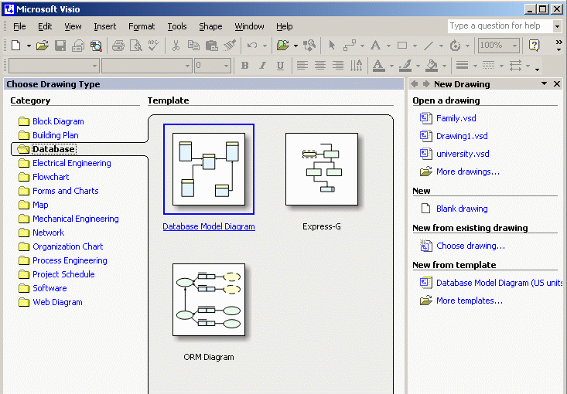
A template (stencil) is simply a set of common shapes and connectors used in the type of drawing specified. Some templates only have a couple of shapes while others have dozens. Visio lets you use multiple templates on the same drawing if necessary. Only one template will be necessary to draw our ER diagrams.
Visio will then give you a blank worksheet (like graph paper) and the template containing the basic shapes and connectors for the chosen drawing type. Most crow's foot ER diagrams can be created with just two of the seven basic database shapes and connectors: entity and relationship.
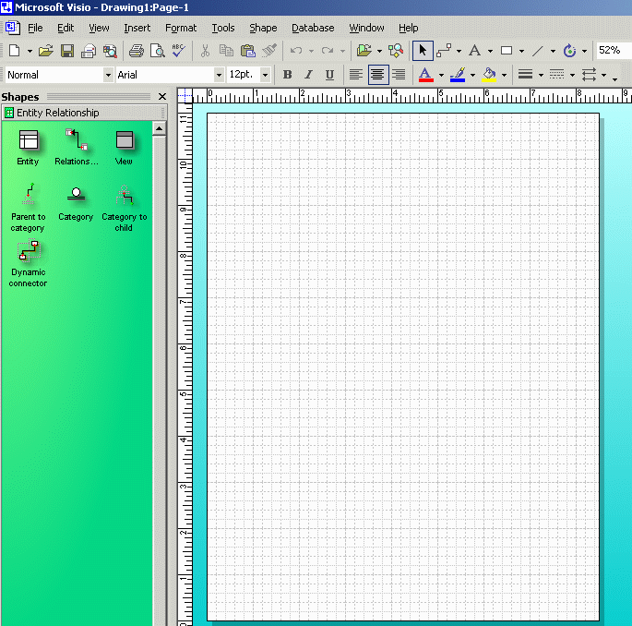
If your initial worksheet appears in the portrait orientation (as in this example), then you might want to rotate it to landscape orientation to make more effective use of your rectangular screen. To do this, select the Page Setup option from the File drop-down menu.
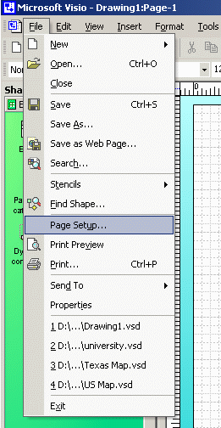
In addition to the worksheet orientation, Page Setup allows you to change the scaling, paper size, margins, etc.
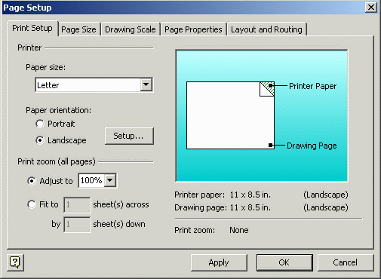

Entities
Begin creating your ER diagram by clicking the Entity (table) shape on the green template.
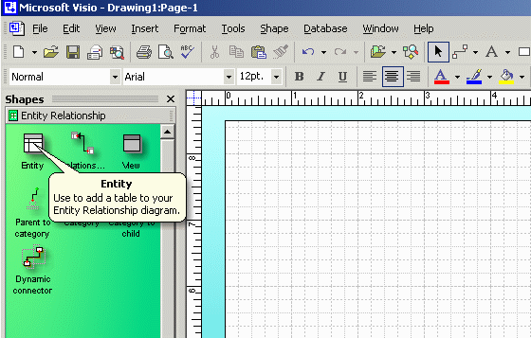
Drag the entity shape to your worksheet. You can reposition it at any time. You can delete any shape by clicking it and pressing the delete key.
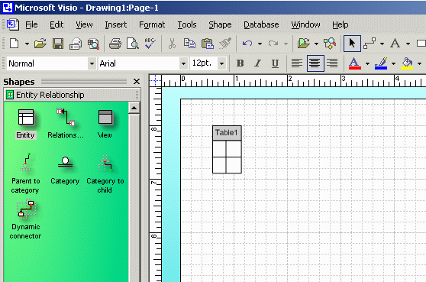
Double click the entity to view/edit its name, columns (fields), primary key, secondary indices, etc.
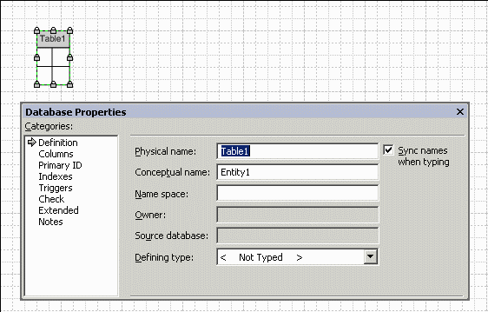
Change the default name (Table1) of the entity to tblParent. Visio allows you to specify different physical and conceptual names for each entity. Since the Sync Name property has been selected, you only need to enter one new name for the table.
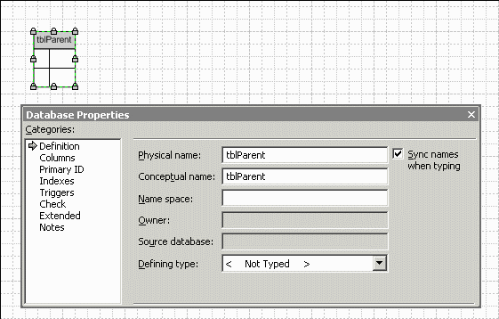
Switch to the Columns (fields) category.
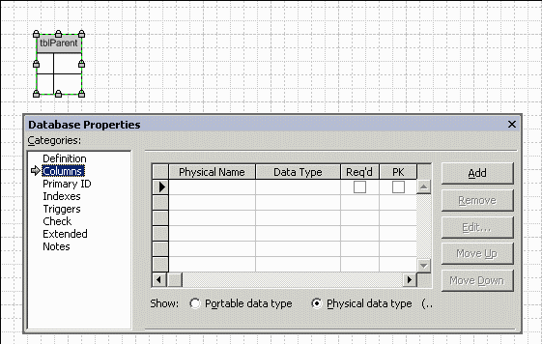
Enter the names of the five fields in the table. The order isn't particularly significant.
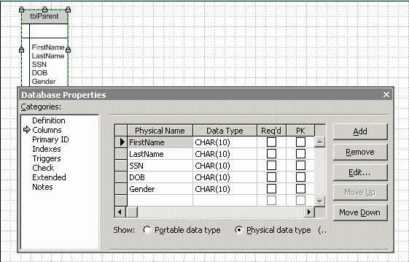
Visio assigns a default data type of ten character text to all new columns. If desired, you can change the columns to their correct data types. Of course, this will have no impact on the appearance of the drawing.
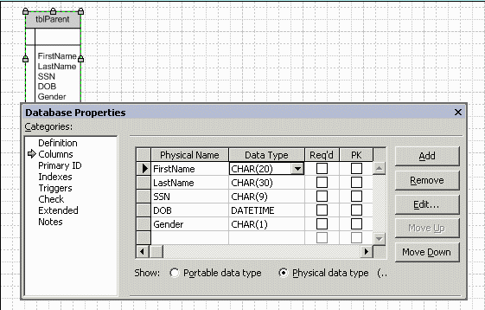
Indicate the Required and Primary Key (PK) status for each field. Notice that Visio underlines the key field and moves it to the top of the diagram. We will change this shuffling behavior later.
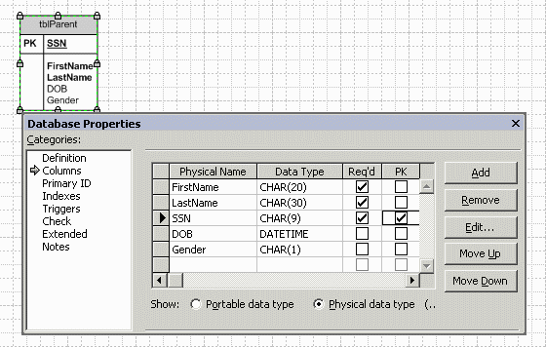
The three required fields of the table are shown in boldface and the two optional fields are shown in standard face.
You can change the font size by selecting the entity then picking a size from the drop-down menu. You can also change the font family, color, alignment, etc.
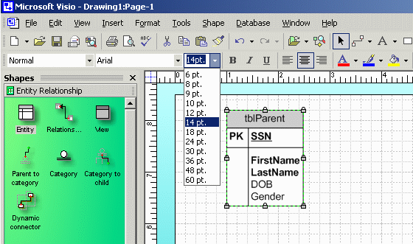

Relationships
Follow the same basic steps to create a second table. Notice that the tblChild table contains two social security number fields. SSN is the unique ID for the child and MotherSSN is the ID for the child's mother. MotherSSN will be a foreign key (pointer) to tblParent.
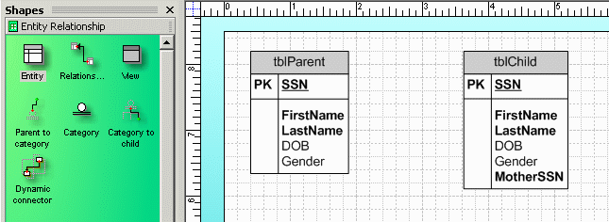
Click the Relationship connector in the template.
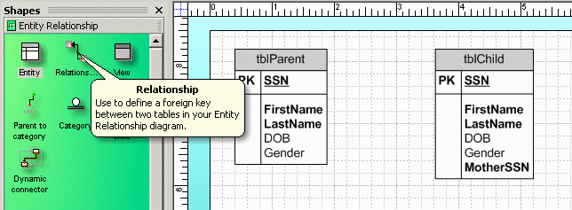
Drag and drop the relationship connector to any blank space in your diagram. Notice that it appears as an arrow. We will change it to a crow's foot later.
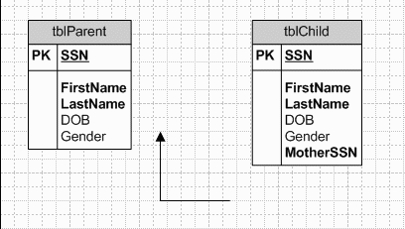
Click the end of the relationship connector with the arrowhead. Drag it over tblParent until the border turns red.
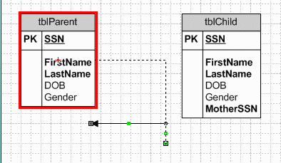
Drag the other end of the relationship connector over tblChild.
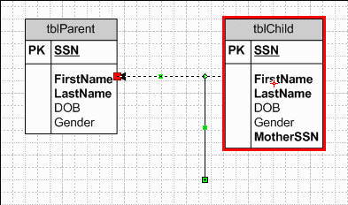
It is very important that you connect the tables in the proper direction. The arrowhead must be on the one-side (i.e., parent-side) and the tail must be on the many-side (i.e., child-side) of every relationship. (Remember: In Codd's relational database model, children point to their parents. Parents do not point to their children.)
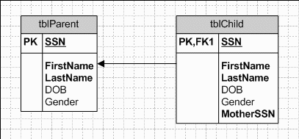
It takes a sharp eye to realize that something has gone wrong. Do you see it?
When you created the relationship between tblParent and tblChild, Visio assumed you wanted to use SSN as the matching fields. Unfortunately, that assumption is only half right. You want SSN in tblParent to match MotherSSN in tblChild. To correct this foreign key mistake, double click the relationship.
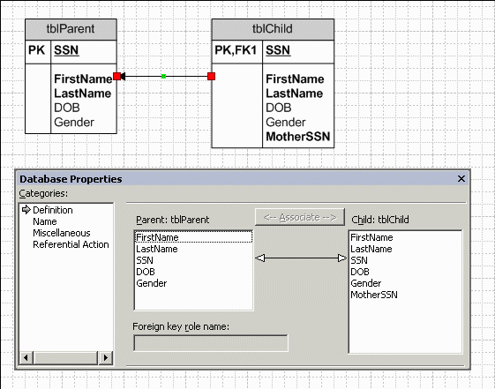
Highlight SSN in tblParent and MotherSSN in tblChild, then click the Associate button.
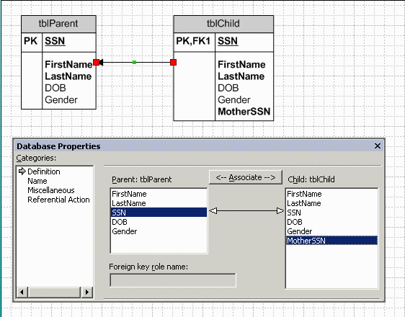
Now MotherSSN correctly appears as a foreign key.
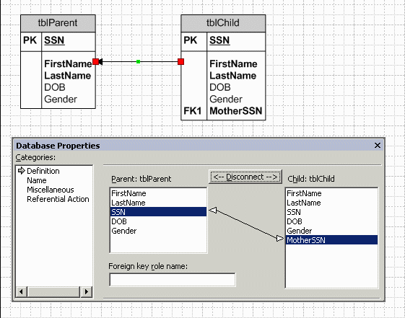
One of the nicest features of Visio is that you can reorganize your diagram by simply moving the entities around. The relationships are automatically adjusted for you. Reorganizing a diagram in PowerPoint or Word, on the other hand, can be very tedious.
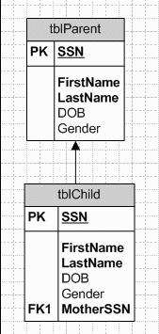

Fine-tuning the Drawing
Many of the basic drawing style options can be accessed by selecting the Database/Options/Document drop-down menu.
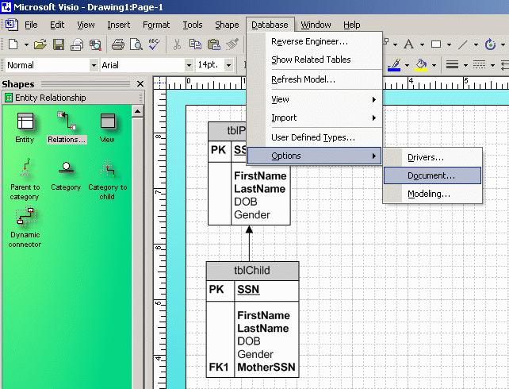
The General tab lets you select the IDEF1X or Relational symbols. It also lets you select which set of entity names to display.
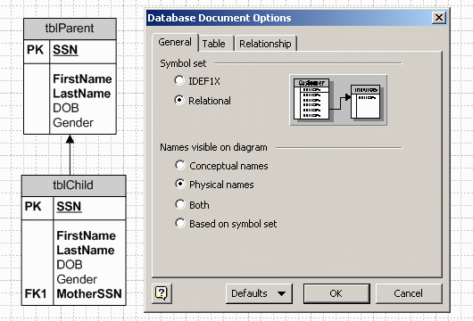
The Table tab lets you select the items to display (e.g., PK, FK, secondary indices, non-key fields, data types). You can also elect to display the primary key fields at the top of each entity or in their actual physical order.
Select the Physical Order option in order to have the two SSN fields displayed in their original (third) positions instead of at the top of tblParent and tblChild above the horizontal lines.
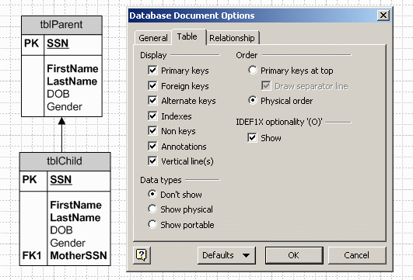
The Relationship tab lets you display the relationships as arrows or as crow's feet.
Select the Crow's Feet option. Notice that the mother-child relationship is shown as mandatory on the one-side and optional on the many-side. We will see how to change this later.
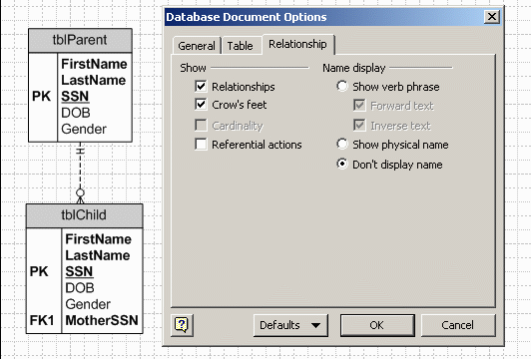
You can reposition the entities on the worksheet and the relationships will automatically be updated.
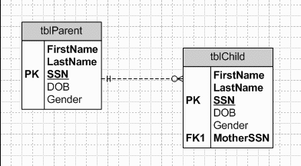
Create a new FatherSSN field in tblChild, then create a one-to-many relationship between SSN and FatherSSN.
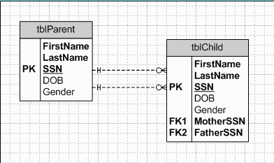
This illustrates one of the problems that Peter Chen tried to solve with his invention of ER diagrams. In particular, our drawing has two relationships that appear identical. We know that one represents motherhood and the other represents fatherhood, but the difference isn't particularly clear in the diagram. Chen proposed that all relationships should be labeled. Unfortunately, his diamond style labels tend to clutter a diagram.
Visio offers a compromise. It lets you add simple labels to individual relationships. To do this, double click a relationship, then enter a descriptive name. In order to minimize clutter, you might want to use short labels like Mom and Dad.
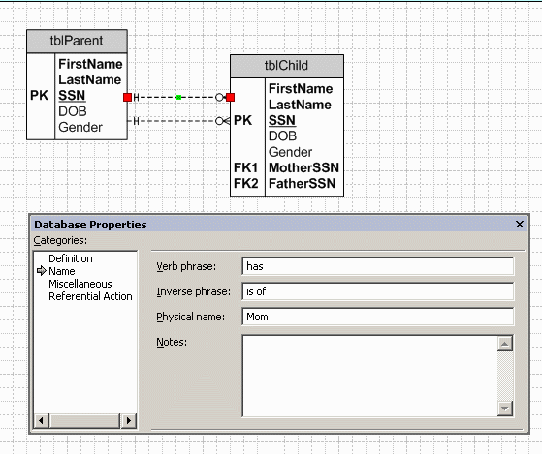
Open the Database/Options/Document drop-down menu, then select the Show Physical Name option from the Relationship tab.
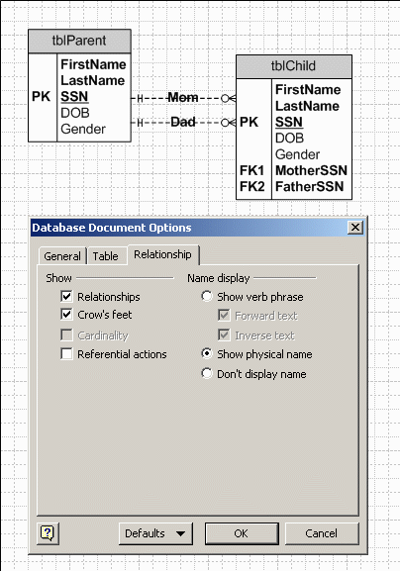
The one-to-many mother and father relationships were created as mandatory on the one-side and optional on the many-side. You can change this by double clicking the relationship. For instance, you can force every tblParent record to have at least one child by changing the mother relationship to One or More cardinality. You can force every parent to have between two and five children by selecting the Range cardinality then specifying the At Least and At Most frequencies.
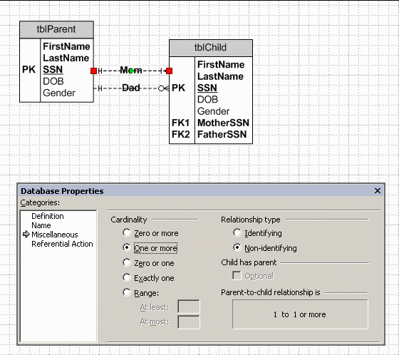
Initially, the mother and father relationships were defined as mandatory on the one-side because MotherSSN and FatherSSN were defined as required fields. If you want to allow a child to not have a father, then de-select the Req'd checkbox for FatherSSN. Now the relationship is optional in both directions.
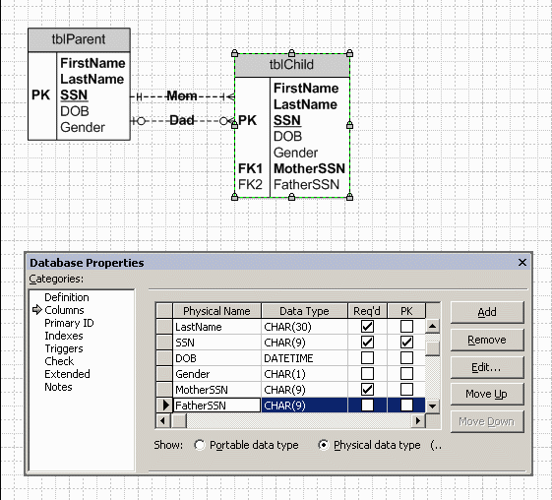

Wrapping Up
Select the File/Save or File/Save As drop-down menu when you are finished with your diagram.
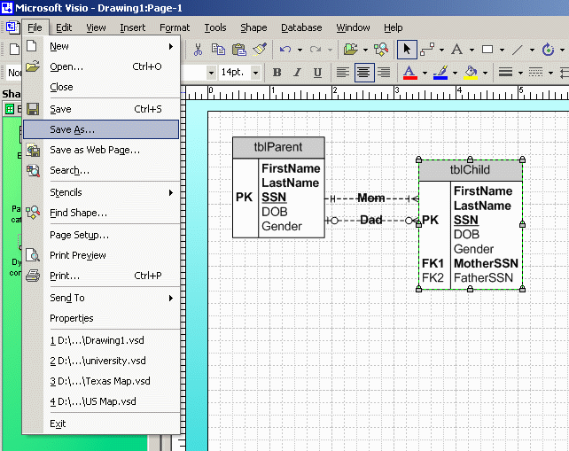
Identify a subdirectory and file name for your new drawing. Note that Visio will use vsd as the extension for all drawing files. In this example, the new file will be named Family.vsd and it will be saved in the Visio subdirectory.
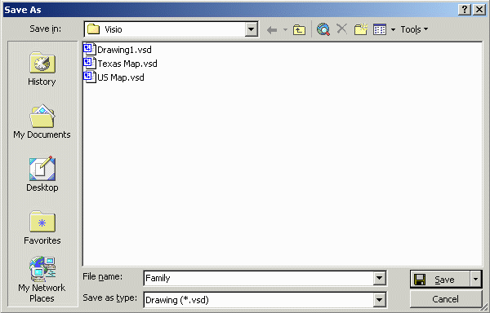

CBA Lab Printing Glitch
Occasionally, some people have problems printing Visio diagrams in the Millennium and Mod labs. In particular, the font is garbled.
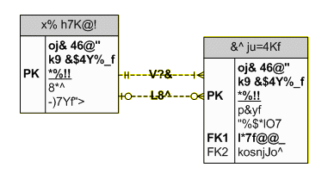
If this occurs to you, then try the following steps.
- Go to the print dialogue box (File/Print),
- Click the Properties button for the desired Mil/Mod Lab printer
- Click the Paper/Quality tab
- Click the Advanced button
- Change the TrueType Font property under the Graphic tree to Download as Softfont

